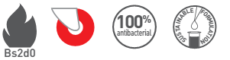

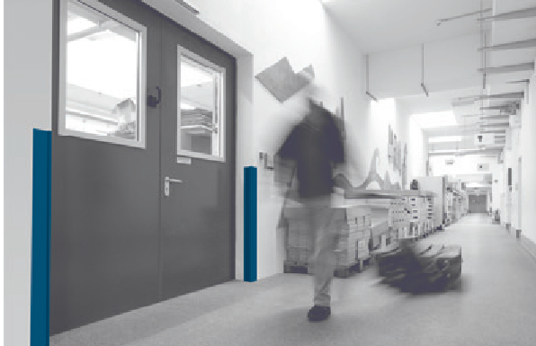

SPECIFICATION

CORNEA
90° CORNER PROTECTOR ON ALUMINIUM CORE

- Description: 90° corner protector on aluminium core (Cornea as manufactured by SPM) from smooth and antibacterial PVC, 2.5 mm thick, achieving Bs2d0 fire rating with solid colour. A protective film is specified to minimise cleaning before acceptance. Wings are 45 mm wide (internal measurement) and snap-fix onto a continuous pre-drilled aluminium core. The corner protector is finished with a smooth PVC endcap.
- Environment: no heavy metals and no substance potentially subjected to any REACH restriction are used in its manufacture, nor PBT/BPA. The calcium-zinc thermal stabilization process is used. The emission level of volatile substance in inside air has been tested according to ISO 16000-6 and is very low (A+) according to the French regulation (23 March 2011 nr 2011-321 Decree and 19 April 2011 Order). 100% of the product are recyclable.
- Colour: selected by architects from manufacturer’s standard range.
- Installation method: snap-fixes onto continuous pre-drilled aluminium core screwed to the wall.
